# CHARITY CLUB

## A PROJECT REPORT

In partial fulfilment for the award of the degree Of

Integrated Certificate Diploma

IN

COMPUTER SCIENCE AND ENGINEERING



|  |  |
| --- | --- |
| **Under the guidance of** | **Submitted by** |
| Dr. Utkarsh | Anand kumar(1915509) |
| Assistant Professor | Abhishek Kumar(1915508) |
| Computer Science and Engineering |  |

SANT LONGOWAL INSTITUTE OF ENGINEERING AND TECHNOLOGY, LONGOWAL – 148106, DISTRICT- SANGRUR, PUNJAB, INDIA

**CERTIFICATE**

Certified that this project report “CHARITY CLUB” submitted by Abhishek Kumar (DCS-CDE/1915508) & Anand Kumar (DCS-CDE/1915509) in the partial fulfilment of the requirements for the award of Bachelor of Technology.

This report has not been submitted to any other University or Institute for the award of any degree.

Anand Kumar (DCS-CDE/1915509)

Abhishek Kumar (DCS-CDE/1915508)

This is to certify that the above statement made by the candidate(s) is correct to the best of my knowledge.

Under the guidance of

Dr. Utkarsh

Assistant Professor

Computer Science and Engineering

The bachelor of technology viva-voice examination of Abhishek Kumar and Anand Kumar was held on 10th May 2022

## **ACKNOWLEDGEMENT**

We would like to express our profound sense of deepest gratitude to our guide Dr. Utkarsh for his valuable guidance, sympathy, and cooperation in providing necessary facilities and sources during the entire period of this project. We wish to convey our sincere gratitude to The Head of Department Computer Science and Engineering Prof. Manoj Sachan and all the faculties of Department Computer Science and Engineering Sant Longowal Institute of Engineering and Technology who have enlightened us during our studies. We express our thanks to all those who helped us in one way or another.

Finally, we would like to say that we are indebted to our parents and friends for everything that they have done for us. All of that would have been impossible without their constant support. And we also thank God for being kind to us and driving us through this journey

## **Abstract**

Charity is the act of extending love and kindness to others unconditionally, which is a conscious act but the decision is made by the heart without expecting a reward. When Charity is carried out selflessly, it is a one-way act where a person gives but asks for nothing in return. It is this act of nature that makes it precious and soulful. Some people believe charity should begin at home but others believe it should originate from the heart. However, charity originates from the heart as you feel the urge of giving, begins from home, ultimately extending to others in the society.

Before you throw away those old clothes you no longer wear, check out these reasons why donating that clothing Will make you feel a lot better about yourself.

Donating clothes is one of the easiest and most satisfying ways to give back to your community.

## **Table of Content**

Certificate i

Acknowledgement ii

Abstract iii

Chapter 1. Introduction…………………………………………………1

Chapter 2. Problem Definition ..2

Chapter 3. Objectives …..3

Chapter 4. Methodology Used …….4-5

Chapter 5. Results and Screenshot…………………………………….6-10

Chapter 6. Conclusion and Future Scope………………………………11

Resources……………………………………………………………...12

**Chapter 1**

**Introduction**

Donating your old clothes and other items to charity is a wonderful way to recycle and stop clothes from going to waste, however, there are both pros and cons to be considered. Sometimes it may be better to skip the middle man entirely and give you clothes directly to the people who need them.

A donation is a [gift](https://en.wikipedia.org/wiki/Gift) for [charity](https://en.wikipedia.org/wiki/Charity_(practice)), [humanitarian aid](https://en.wikipedia.org/wiki/Humanitarian_aid), or to benefit a cause. A donation may take various forms, including [money](https://en.wikipedia.org/wiki/Money), [alms](https://en.wikipedia.org/wiki/Alms), [services](https://en.wikipedia.org/wiki/Service_(economics)), or goods such as [clothing](https://en.wikipedia.org/wiki/Clothing), [toys](https://en.wikipedia.org/wiki/Toy), and other items.

Charity is the act of extending love and kindness to others unconditionally, which is a conscious act but the decision is made by the heart without expecting a reward. When Charity is carried out selflessly, it is a one-way act where a person gives but asks for nothing in return. It is this act of nature that makes it precious and soulful. There are people who believe charity should begin at home but others believe it should originate from the heart. However, charity originates from the heart as you feel the urge of giving, begins from home, ultimately extending to others in the society.

Before you throw away those old clothes you no longer wear, check out these reasons why donating that clothing Will make you feel a lot better about yourself. Donating clothes is one of the easiest and most satisfying ways to give back to your community

By donating old clothes instead of throwing them away, they help conserve the earth's resources and prevent adding unnecessary carbon dioxide to the atmosphere.

**Reasons Why Charity Club is the Best Place to Donate Clothes**

* Charity Club Benefits the Entire Community. In a world that's being globalized faster than we can imagine, supporting your own community has never been more important.
* Protect the Planet.
* Your Clothes Help Other People.
* You're Protecting Kids.
* It's a Teachable Moment.

**Chapter 2**

**Problem Definition**

Charity stores have massive problems with receiving soiled, torn, or otherwise unsuitable textiles that can’t be sold or given away. In some cases, charities are even forced to spend money sorting and disposing of this material, of which an estimated 25% goes directly to landfill.

While donating is always a good idea, many issues can arise preventing the donation from reaching its recipients. That’s why it’s so important to donate clothes the correct way so that the veterans in need receive the donation quickly and effectively.

Charity stores have massive problems with receiving soiled, torn, or otherwise unsuitable textiles that can’t be sold or given away. In some cases, charities are even forced to spend money sorting and disposing of this material, of which an estimated 25% goes directly to landfill.

While it might be tempting to give away more ragged garments, charitable organizations will likely discard these. Donors should not gift anything that they would not personally consider to be wearable.

**Chapter 3**

**Objective**

The main objective of “ Charity club " is to develop a websites, which could be able to donate clothes, Books, shoes,etc.

The main objective of the project is to provide necessary things to millions of poor and needy people who face hardship and health risks due to lack of proper clothing and other basic things in far flung areas.

You can donate anything in good condition that you don’t use anymore which might help someone in need, such as clothes,bed sheets,blankets, shoes, sporting goods, furniture, stationery, books,etc.

* The main objective is to prepare a website, which could help people to find a way to donate anything.

# This may help the needy people by providing them clothes.

# As it gives your clothes new life.

* it does good a lot of good for cloth less people.
* No paperwork required.
* Software is completely computerized, so it is not a time-consuming process.

# **Chapter 4**

## **Methodology Used**

**Website Development**

# **Front End :** The part of a website that the user interacts With directly is termed the front end. It is also referred to as the ‘client Side’ of the application. Like HTML, CSS, JS. HTML , CSS & JavaScript for developing Menu page, Home page, Login page , contact, & Signup page.

* **HTML:**  HTML stands for Hyper Text Markup Language. HTML is the standard markup language for Web pages. HTML **elements** are the building blocks of HTML pages. HTML elements are represented by **<> tags.**
* **CSS:** CSS stands for Cascading Style Sheets. It is a style sheet language which is used to describe the look and formatting of a document written in markup language. It provides an additional feature to HTML.
* **JavaScript:** JavaScript is the Programming Language for the Web. JavaScript can update and change both HTML and CSS. JavaScript can calculate, manipulate and validate data.

1. **Back End:** It is the server-side of the website. It Stores and arranges data, and also makes sure everything on the client-Side of the website works fine. It is the part of the website that you Cannot see and interact with. It is the portion of software that does not Come in direct contact with the users. Like PHP Mysql.Use PHP & Mysql to store the user’s data.

* **PHP:** Php is a recursive acronym for "PHP: Hypertext Preprocessor". PHP is a serverside scripting language that is embedded in HTML. It is used to manage dynamic content, databases, session tracking, even build entire e-commerce sites
* **MySQL:** MySQL creates a database for storing and manipulating data, defining the relationship of each table. Clients can make requests by typing specific SQL statements on MySQL.The server application will respond with the requested information and it will appear on the clients’ side.

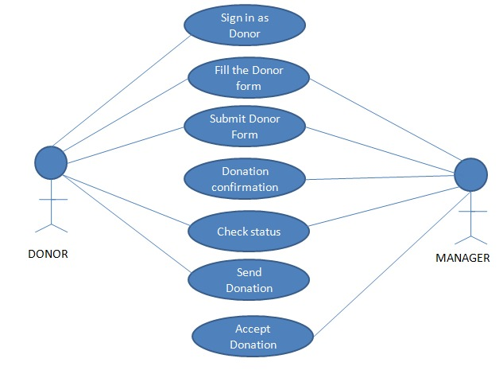

**Fig1: Donation Mnagement Subsystem**

**Chapter 5**

**Result and Screenshots**

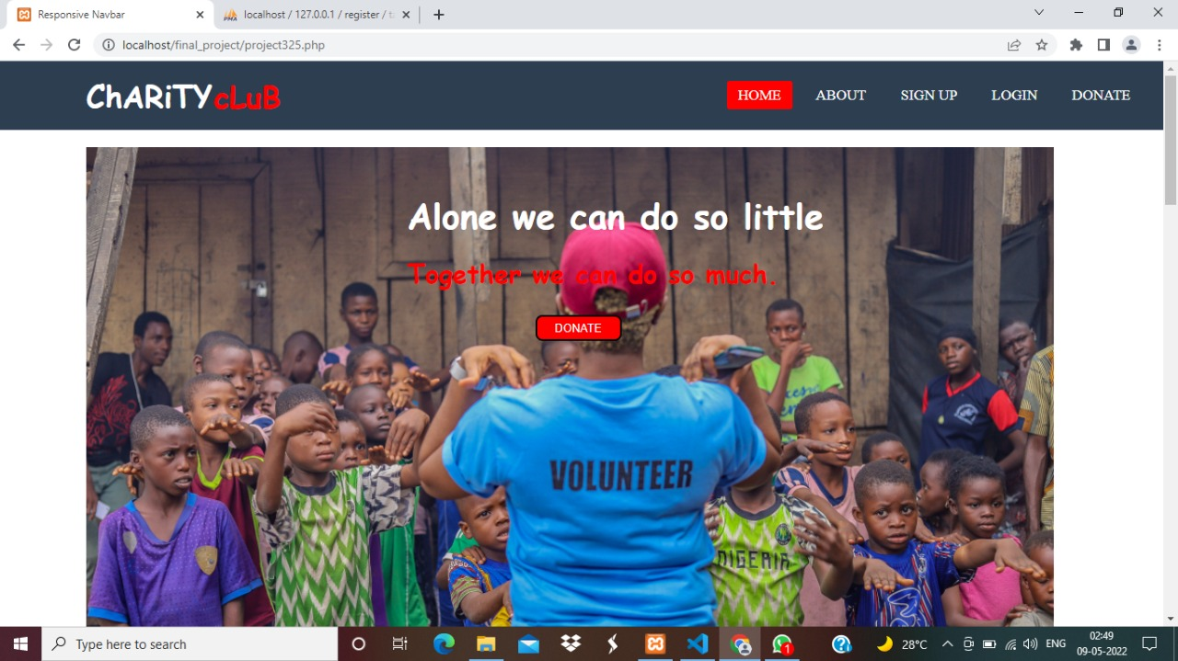

**Fig2: Home page**

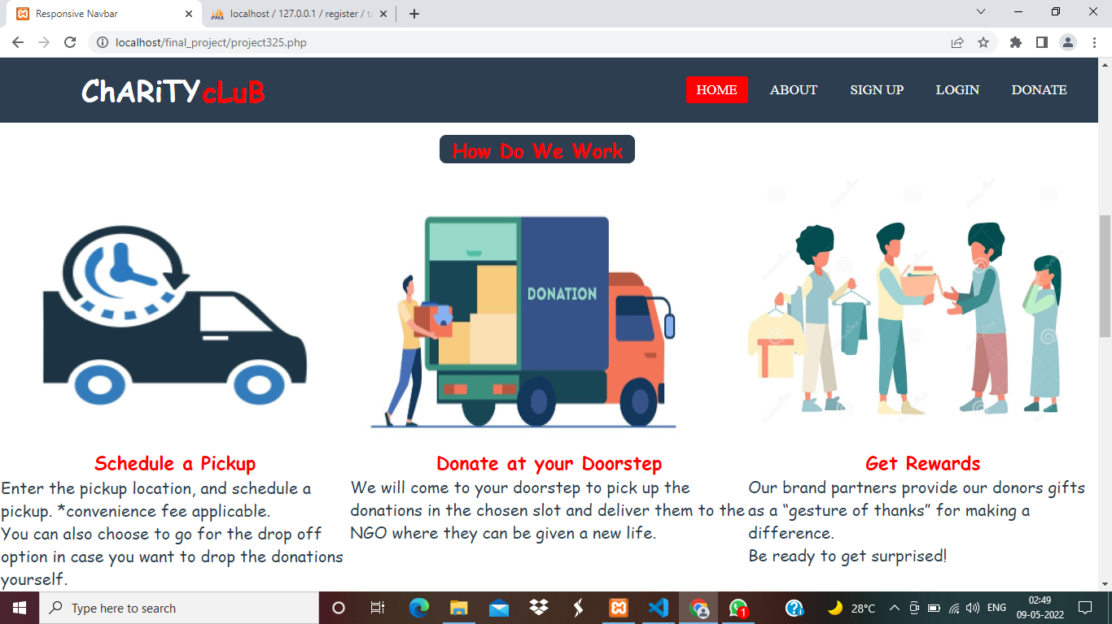

**Fig3: Home page**

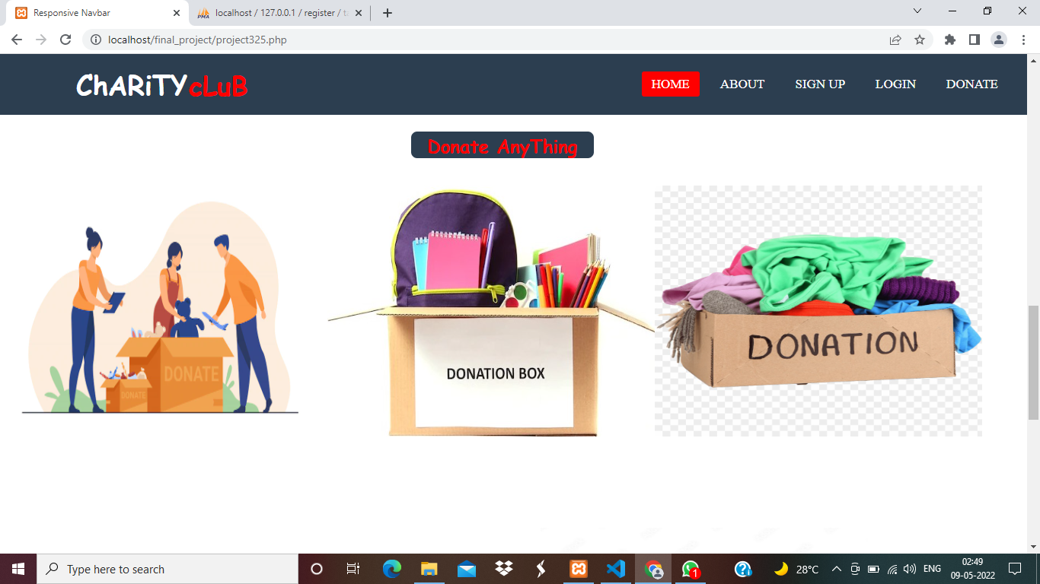

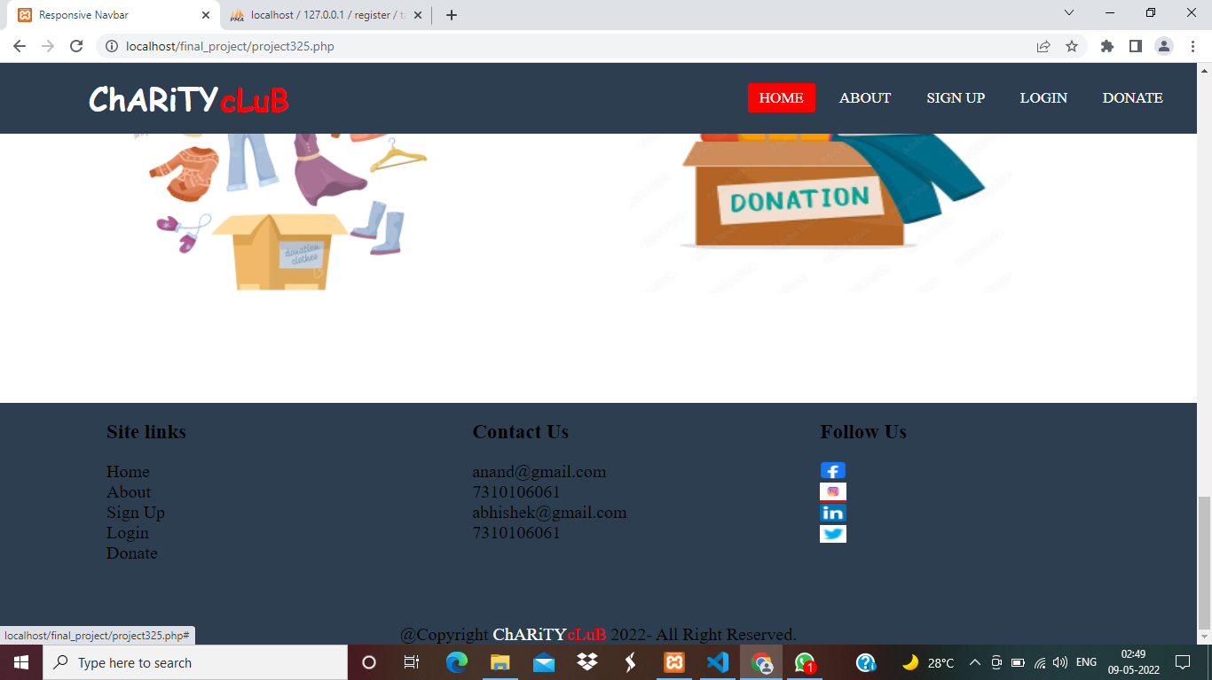**Fig4: Home page**

**Fig5: Home page**

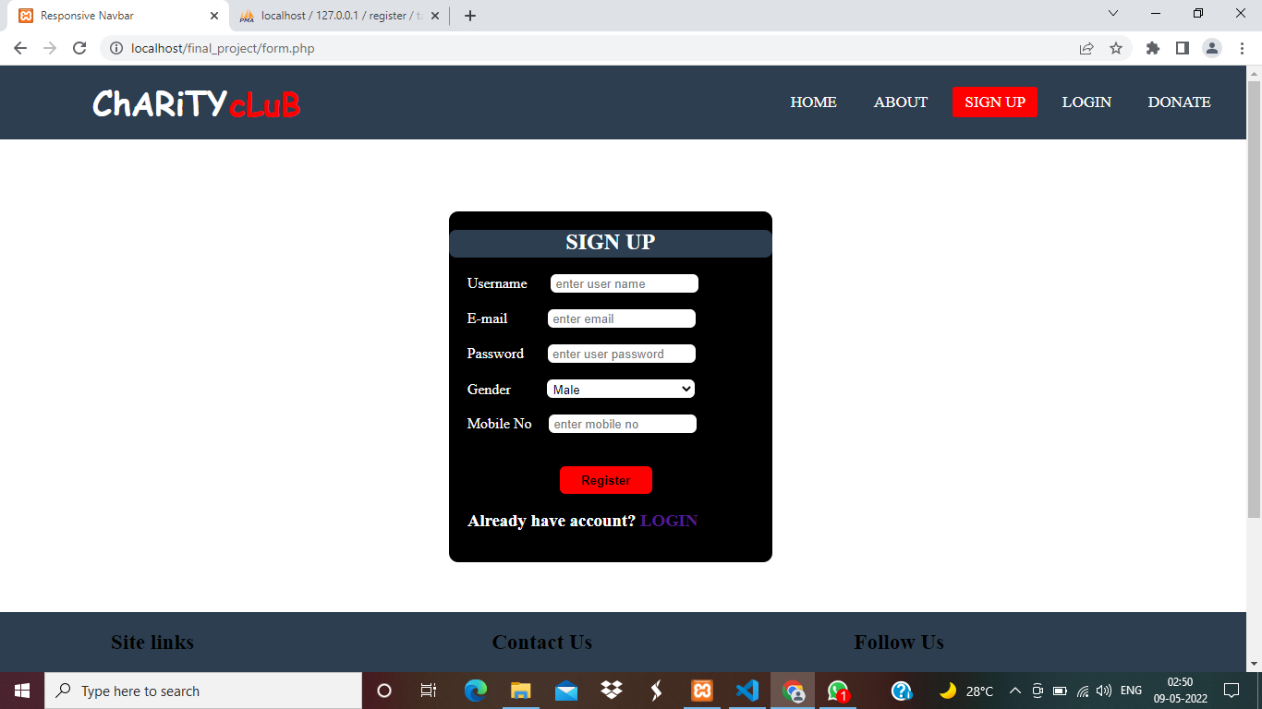**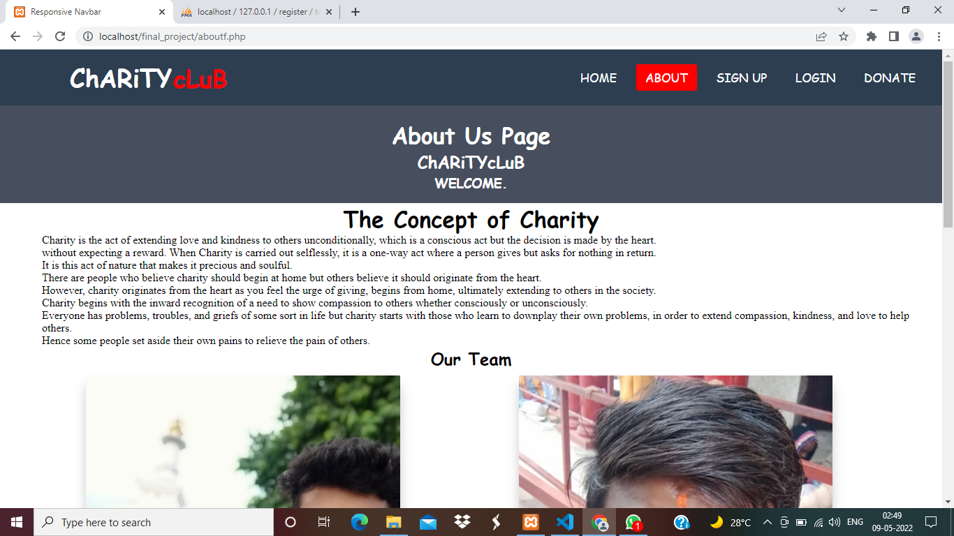 Fig6: About page**

**Fig7: Signup Page**

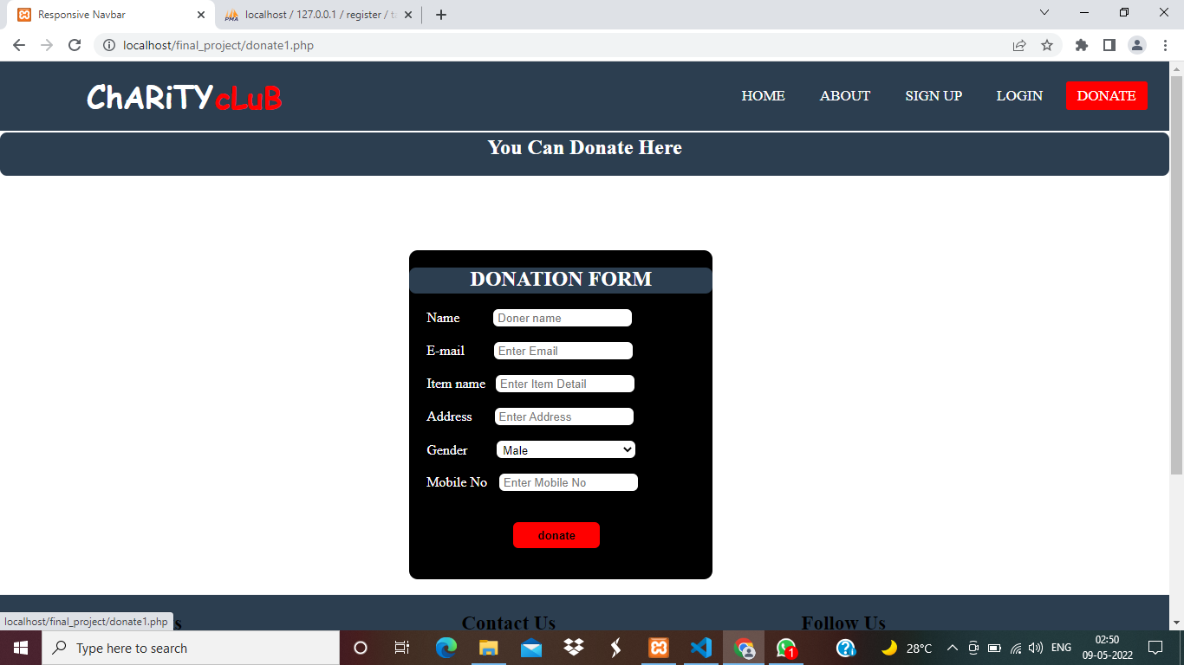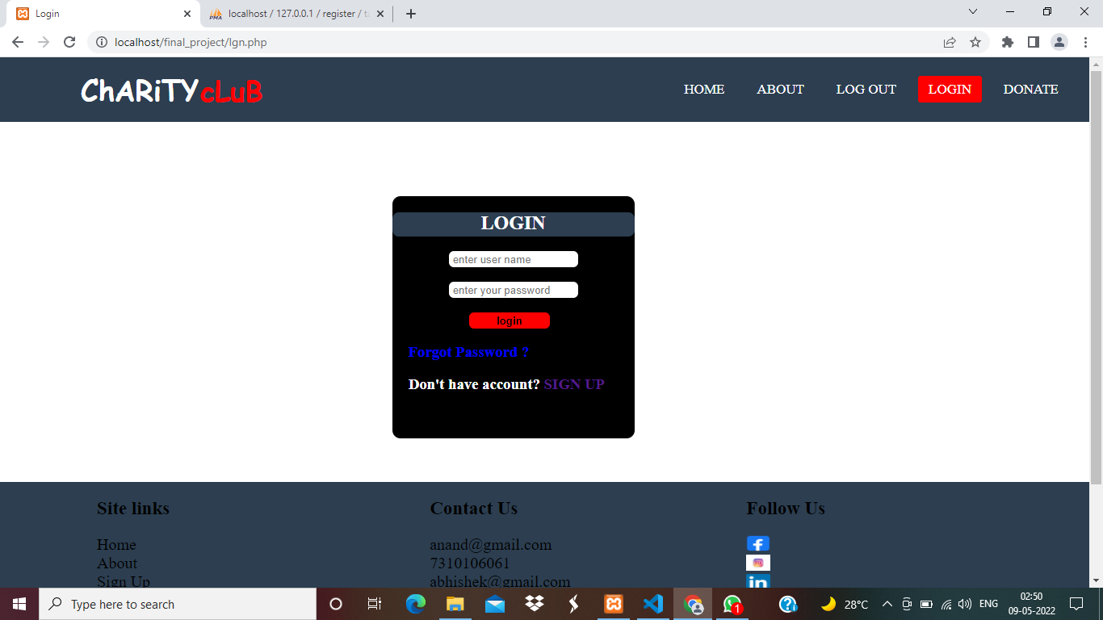 **Fig8: Login Page**

**Fig9: Donation Form**

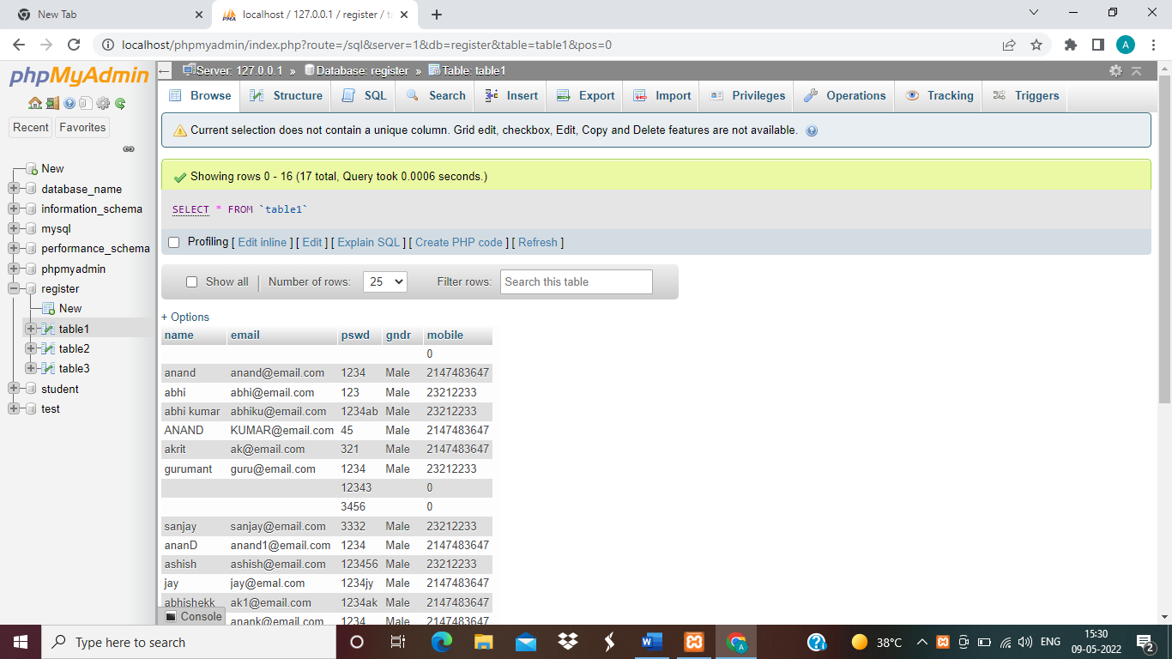 **Fig10: Backend**

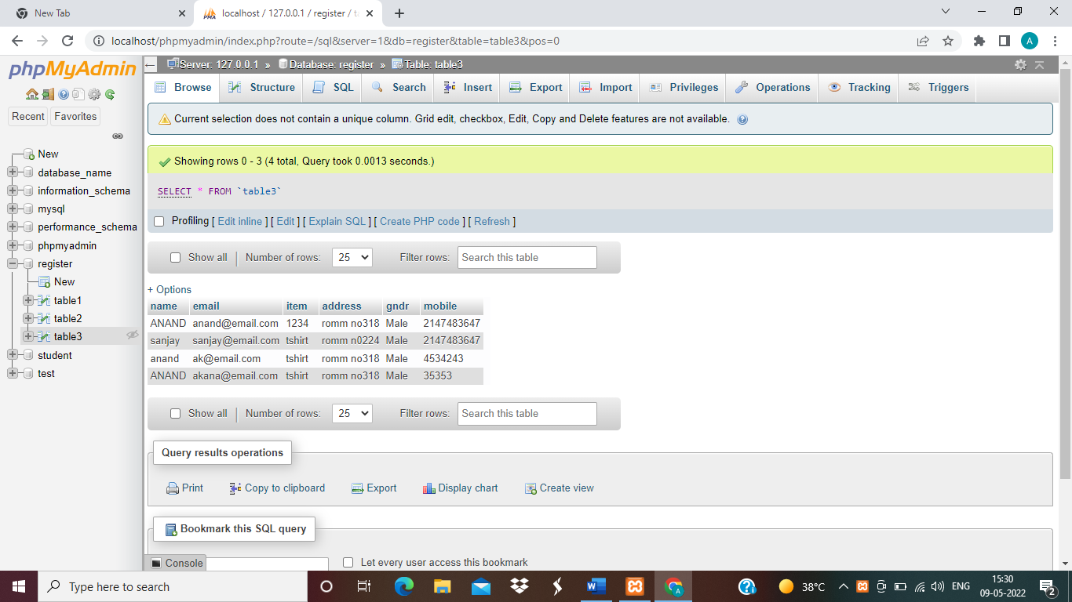

**Fig11: Donation Details**

**Chapter 6**

**Future Scope and Conclusion**

**Future Scope** This project was developed to fulfill user requirements; however, there is lots of scope to improve the performance of the Charity Club websites of user interface, database performance, and query processing time, Feedback form Etc. So, there are many things for future enhancement of this project. The future enhancements that are possible in the project are as follows.

* Update on Feedback Form
* In the area of data security and system security.
* More changes, like OTP verification.
* Addition of more interesting features for users.
* Easy user interfaces and many more.

**Conclusion:** The Charity Club is used for Donate anything. It is developed using HTML,CSS, JS and PHP MySQL in backend which fully meets the objectives of the system which it has been developed. The system has reached a steady state where all bugs have been eliminated. The system is operated at a high level of efficiency and all the staff and user associated with the system understands its advantage. The system solves the problem. It was intended to solve as requirement specification.

## **Resources**

* + <https://www.w3schools.com/html>
  + <https://www.tutorialspoint.com/html/>
  + <https://www.geeksforgeeks.org/html>
  + <https://www.phpmyadmin.net>
  + <https://locallhost.me/phpmyadmin>
  + Geeks For Geeks
  + Javatpoint
  + Tutorialspoint
  + Youtube
  + pictures/images Google Image Search